**Set Up Selenium Grid:**

**1.Download Selenium standalone Server jar file from https://www.seleniumhq.org/download/ link.**

**2.After execute this command :java -jar selenium-server-4.10.0.jar hub**

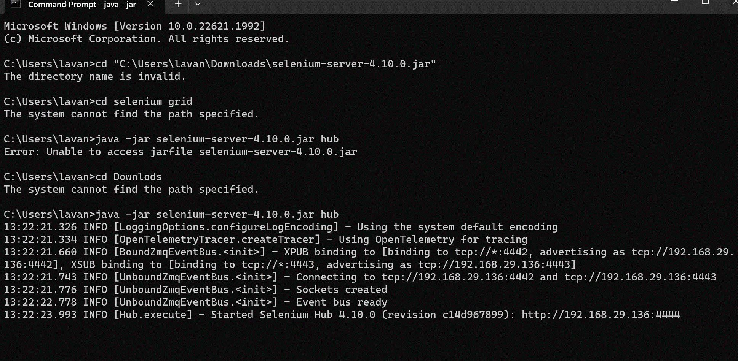

**3. Open chrome browser - Enter URL as http://localhost:4444**

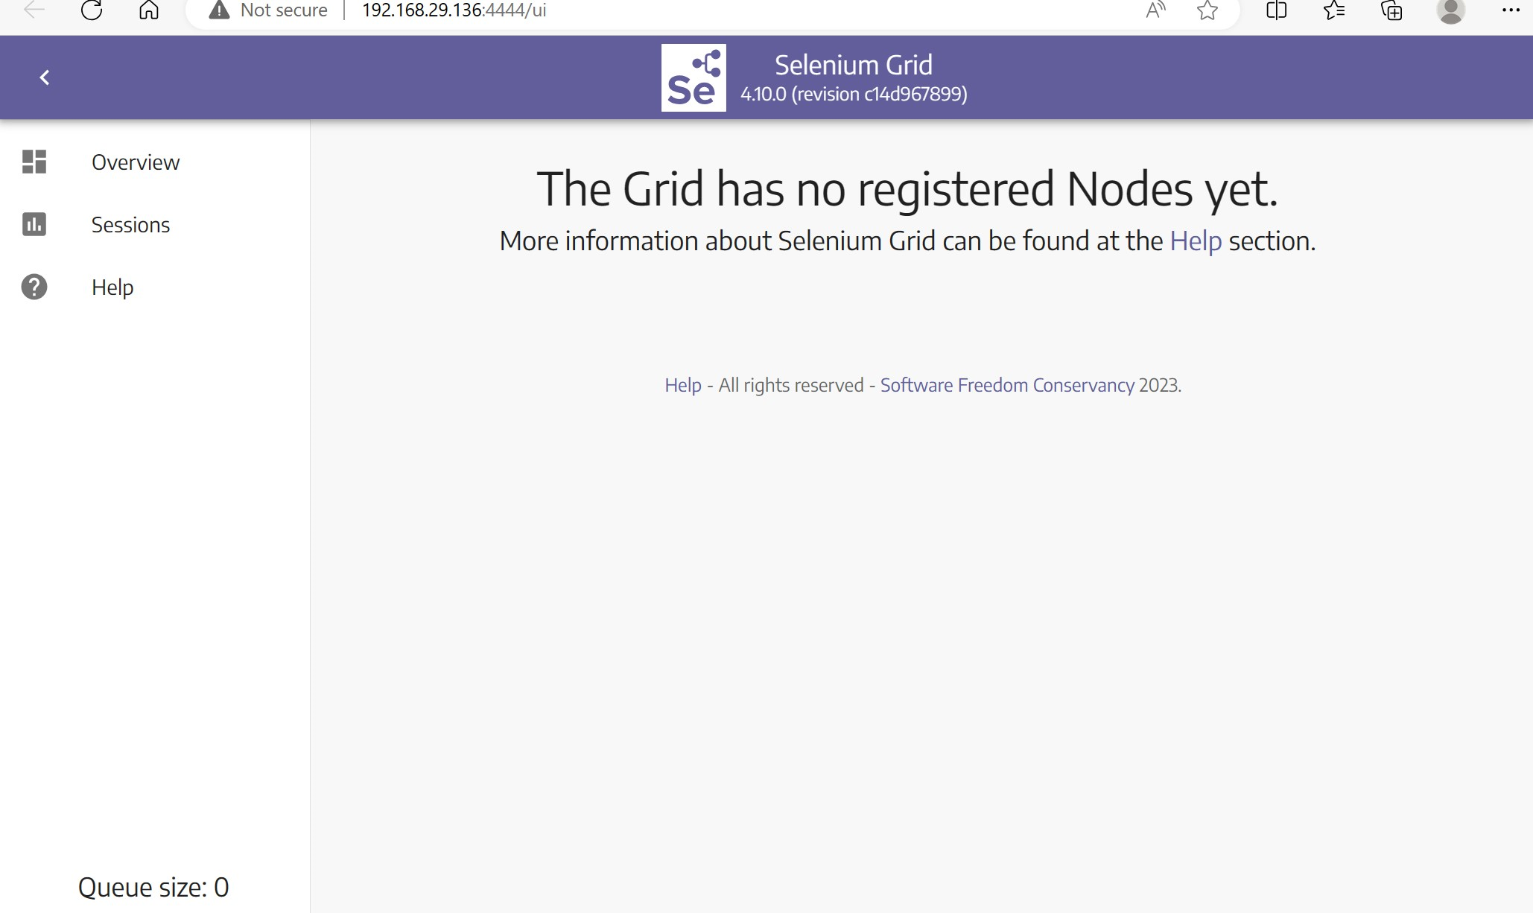

**4. java - Dwebdriver.chrome.driver=C:\Users\lavan\Downloads\chromedriver - jar selenium-server-4.10.0.jar node**

